**IRELAND DIABETES CARE DEVICES MARKET**

According to Intelli, the Ireland Diabetes Care Devices Market was valued at USD 117.54 million in 2024 and is projected to reach USD 211.65 million by 2032, growing at a CAGR of 8.53% from 2024 to 2032.

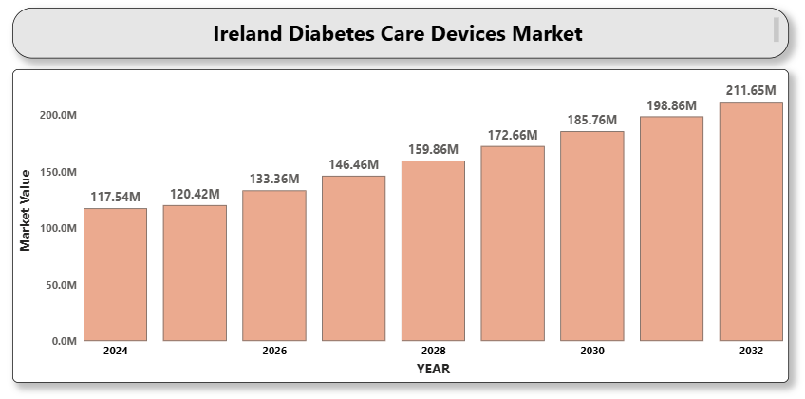

The Ireland diabetes care devices market is experiencing steady growth, driven by the rising prevalence of diabetes, technological advancements, and increasing public awareness regarding diabetes management. The government's focus on healthcare infrastructure, coupled with the adoption of innovative glucose monitoring technologies, is facilitating market expansion. Favorable reimbursement policies, an expanding geriatric population, and increasing obesity rates are also major contributing factors. Technological innovations like smart insulin pens, closed-loop insulin delivery systems, and integration with mobile health apps are significantly enhancing diabetes management efficiency. As a result, both domestic and global players are finding significant opportunities within this market.

**Ireland Diabetes Care Devices Market Definition**

Diabetes care devices are medical instruments designed to monitor and manage blood glucose levels among diabetic patients. These devices include blood glucose meters, continuous glucose monitoring (CGM) systems, insulin pumps, insulin pens, and lancets. They aid in early detection, routine monitoring, and better management of diabetes, thereby minimizing complications such as cardiovascular diseases, kidney disorders, and nerve damage. The development of advanced devices with integrated digital technologies for real-time data transmission and analysis is reshaping diabetes management across healthcare settings and homecare environments. The trend towards minimally invasive and non-invasive monitoring systems is further driving innovation in the industry.

**Ireland Diabetes Care Devices Market Overview**

The growing diabetic population, particularly type 2 diabetes, is a primary driver for the Ireland diabetes care devices market. Increasing healthcare expenditure, supportive government policies, and technological advancements in glucose monitoring and insulin delivery systems are enhancing market growth. The adoption of telehealth platforms and remote patient monitoring solutions post-pandemic has further accelerated the demand for diabetes care technologies. However, market expansion faces challenges such as high device costs, reimbursement limitations in some categories, and concerns related to device accuracy and cybersecurity vulnerabilities. Nonetheless, the increasing adoption of continuous glucose monitoring (CGM), flash glucose monitoring systems, and wearable insulin delivery devices presents substantial growth opportunities. The market is also witnessing trends such as patient preference for user-friendly and mobile-connected devices.

**Ireland Diabetes Care Devices Market Segmentation Analysis**

**Market Segmentation by Product Type:**

* Blood Glucose Monitoring Devices
* Continuous Glucose Monitoring (CGM) Systems
* Insulin Delivery Devices
* Others

Blood glucose monitoring devices held the largest market share in 2024, owing to their affordability and widespread usage among diabetic patients for daily blood sugar tracking. However, continuous glucose monitoring systems are expected to witness the fastest growth during the forecast period due to their real-time tracking capability, better glucose management, and enhanced patient compliance.

**Market Segmentation by End-User:**

* Hospitals & Clinics
* Homecare Settings
* Diagnostic Centers

Hospitals and clinics represent the dominant end-user segment due to their advanced infrastructure, professional monitoring requirements, and increasing government investments in healthcare facilities. However, homecare settings are emerging rapidly owing to the rising preference for self-monitoring among patients, the aging population, cost-effectiveness, and increased device portability. Diagnostic centers are also gaining traction with the rising demand for periodic screening.

**Market Segmentation by Application:**

* Type 1 Diabetes
* Type 2 Diabetes
* Gestational Diabetes

Type 2 diabetes holds the majority share in the market, driven by the increasing number of elderly and obese individuals in Ireland. The growing sedentary lifestyle, unhealthy eating habits, and genetic predispositions are major factors contributing to this trend. The rising incidence of gestational diabetes and awareness programs initiated by government and private organizations further fuel the demand for diabetes care devices among pregnant women.

**Key Players**

Major companies operating in the Ireland Diabetes Care Devices Market include Abbott Laboratories, Medtronic plc, F. Hoffmann-La Roche Ltd., Dexcom, Inc., Ascensia Diabetes Care Holdings AG, Insulet Corporation, Tandem Diabetes Care, Inc., Becton, Dickinson and Company (BD), Ypsomed AG, and Terumo Corporation. Our analysis provides insights into financial statements, product benchmarking, and SWOT analysis for each of these players.

**Key Developments**

* In 2025, Dexcom received CE mark approval for G8 CGM systems, expanding their presence across European markets including Ireland and offering more compact sensors with extended battery life.
* In 2024, Medtronic launched the MiniMed 780G system in select European markets, an advanced hybrid closed-loop system with personalized insulin delivery.

**Market Attractiveness**

The visual representation of market attractiveness highlights the key factors driving growth in Ireland, such as favorable healthcare policies, high disease prevalence, strong insurance support, and rising technological integration. The strong focus on digital health and preventive healthcare strategies further boosts the attractiveness of the Ireland market.

**Porter's Five Forces**

An analysis of Porter's Five Forces illustrates the competitive landscape of the Ireland diabetes care devices market, highlighting the bargaining power of suppliers and buyers, the threat of new entrants, the threat of substitutes, and competitive rivalry. The presence of established players, continuous technological advancements, and high regulatory standards intensify competition.

**TABLE OF CONTENTS**

**1 INTRODUCTION OF IRELAND DIABETES CARE DEVICES MARKET**

1.1 Overview of the Market

1.2 Scope of Report

1.3 Assumptions

**2 EXECUTIVE SUMMARY**

**3 RESEARCH METHODOLOGY**

3.1 Data Mining

3.2 Validation

3.3 Primary Interviews

3.4 List of Data Sources

**4 IRELAND DIABETES CARE DEVICES MARKET OUTLOOK**

4.1 Overview

4.2 Market Dynamics

* Drivers
* Restraints
* Opportunities
* Trends

4.3 Porter's Five Force Model

4.4 Value Chain Analysis

**5 IRELAND DIABETES CARE DEVICES MARKET, BY PRODUCT TYPE**

* Blood Glucose Monitoring Devices
* Continuous Glucose Monitoring (CGM) Systems
* Insulin Delivery Devices
* Others

**6 IRELAND DIABETES CARE DEVICES MARKET, BY END USER**

* Hospitals & Clinics
* Homecare Settings
* Diagnostic Centers

**7 IRELAND DIABETES CARE DEVICES MARKET, BY APPLICATION**

* Type 1 Diabetes
* Type 2 Diabetes
* Gestational Diabetes

**8 IRELAND DIABETES CARE DEVICES MARKET COMPETITIVE LANDSCAPE**

8.1 Overview

8.2 Company Market Ranking

8.3 Key Development Strategies

**9 COMPANY PROFILES**

**9.1 Abbott Laboratories**

9.1.1 Overview

9.1.2 Financial Performance

9.1.3 Product Outlook

9.1.4 Key Developments

**9.2 Medtronic plc**

9.2.1 Overview

9.2.2 Financial Performance

9.2.3 Product Outlook

9.2.4 Key Developments

**9.3 F. Hoffmann-La Roche Ltd.**

9.3.1 Overview

9.3.2 Financial Performance

9.3.3 Product Outlook

9.3.4 Key Developments

**9.4 Dexcom, Inc.**

9.4.1 Overview

9.4.2 Financial Performance

9.4.3 Product Outlook

9.4.4 Key Developments

**9.5 Ascensia Diabetes Care Holdings AG**

9.5.1 Overview

9.5.2 Financial Performance

9.5.3 Product Outlook

9.5.4 Key Developments

**9.6 Insulet Corporation**

9.6.1 Overview

9.6.2 Financial Performance

9.6.3 Product Outlook

9.6.4 Key Developments

**9.7 Tandem Diabetes Care, Inc.**

9.7.1 Overview

9.7.2 Financial Performance

9.7.3 Product Outlook

9.7.4 Key Developments

**9.8 Becton, Dickinson and Company (BD)**

9.8.1 Overview

9.8.2 Financial Performance

9.8.3 Product Outlook

9.8.4 Key Developments

**9.9 Ypsomed AG**

9.9.1 Overview

9.9.2 Financial Performance

9.9.3 Product Outlook

9.9.4 Key Developments

**9.10 Terumo Corporation**

9.10.1 Overview

9.10.2 Financial Performance

9.10.3 Product Outlook

9.10.4 Key Developments

**10 KEY DEVELOPMENTS**

* Product Launches/Developments
* Mergers and Acquisitions
* Business Expansions
* Partnerships and Collaborations

**11 APPENDIX**

* Related Research